Stratton Hospitality’s Branding Guide

# Logo Guide

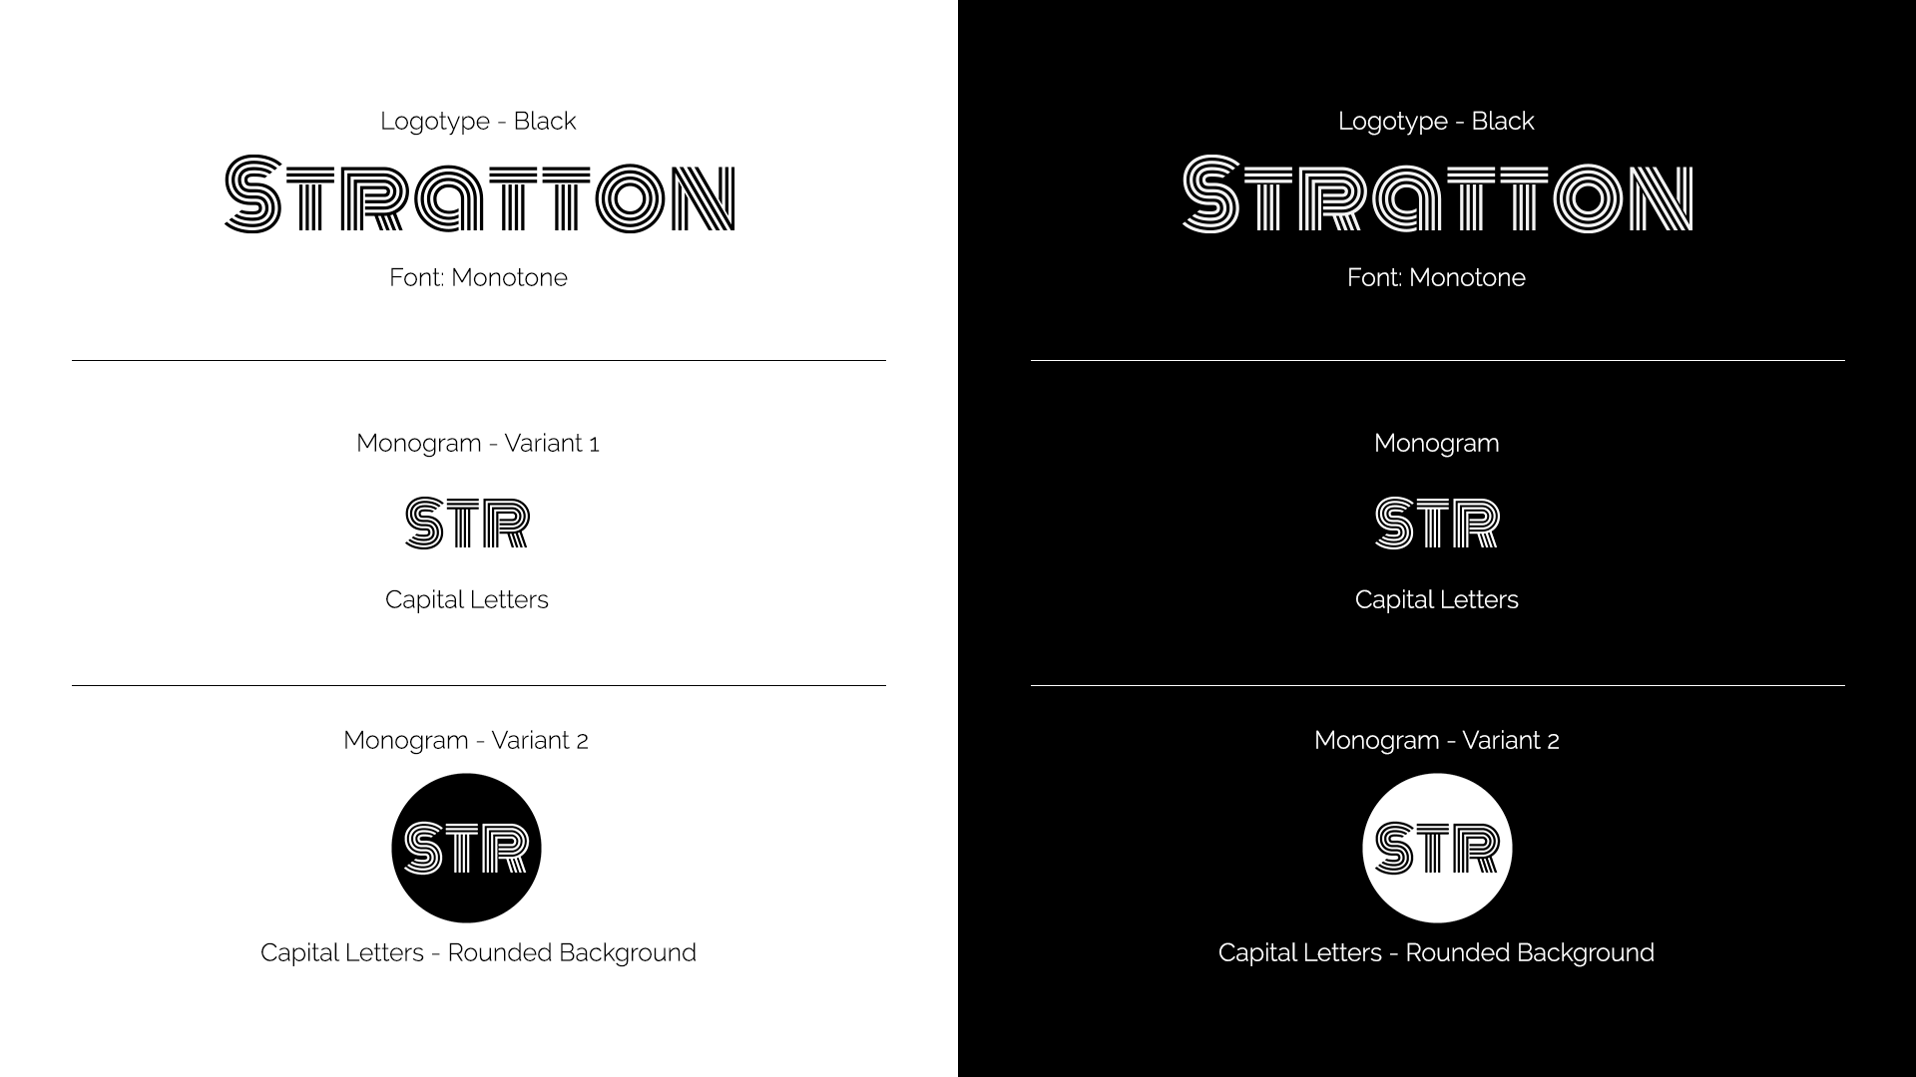

# Logo Usage

* Use black logos only in white backgrounds.
* Use white logos in solid backgrounds.
* Use Monograms as Profile Pictures. Preferably black monogram with white background.
* Do not distort the logo.
* Do not change the logotype font.
* Resize proportionally.

See the examples below.

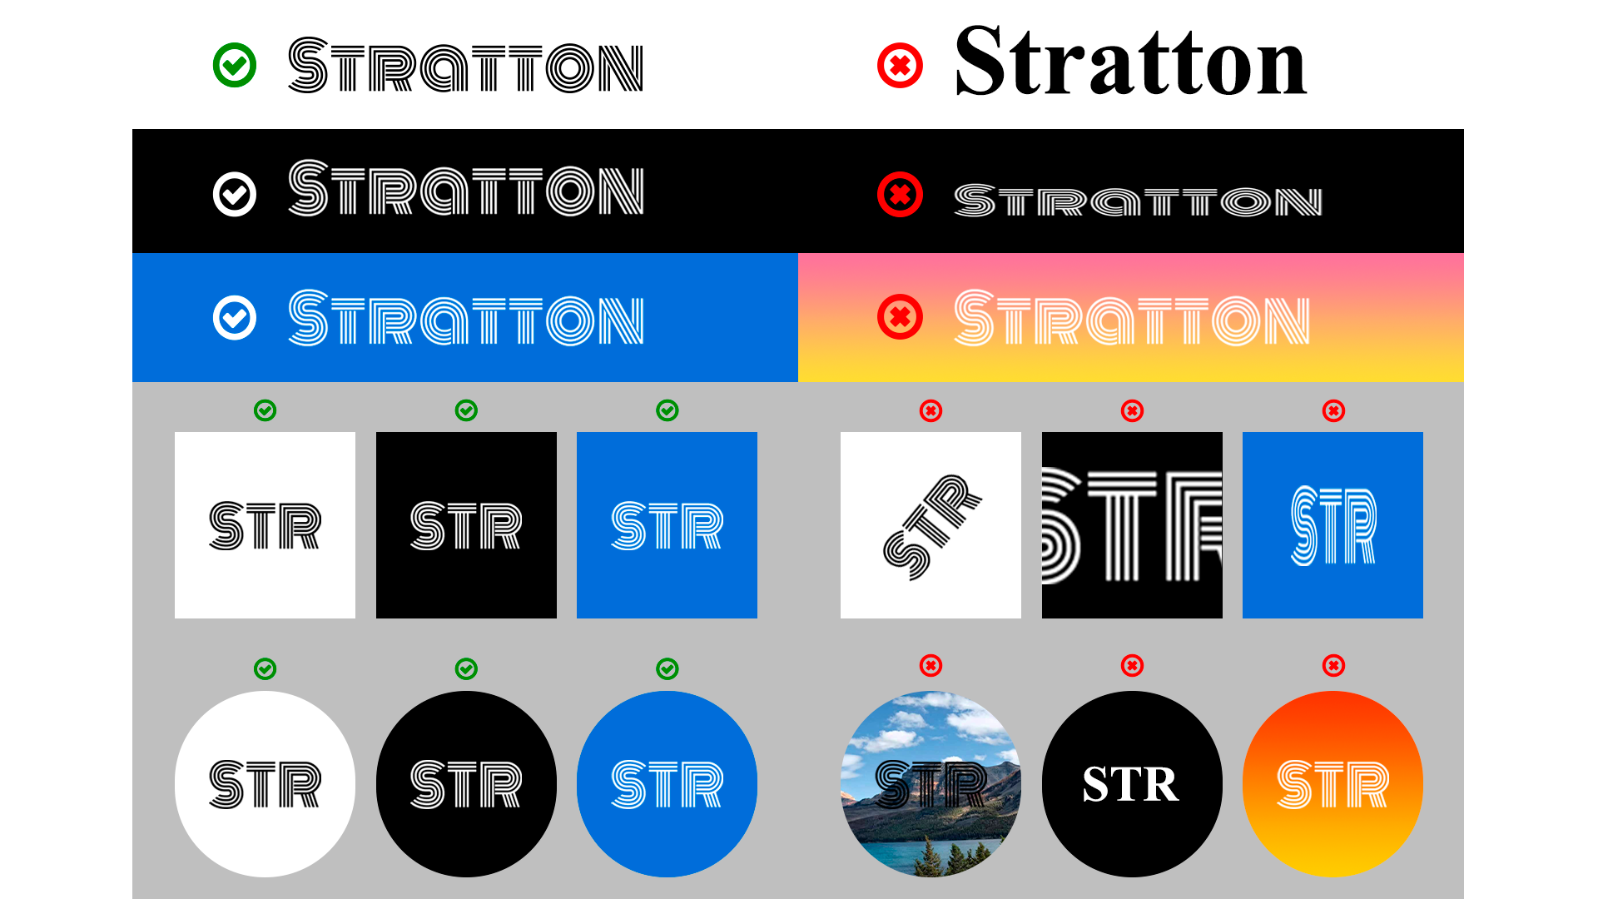

# Color Scheme

| #0A3FF7 | #096DD6 | #15B7ED | #09D6D3 | #0AF7B1 |
| --- | --- | --- | --- | --- |

# Fonts

Monoton - Just for logo

Raleway - For headings and body text

# Branding Assets

[Stratton Letterhead](https://drive.google.com/a/truststratton.com/open?id=1pMySxSyklqyIYeYa7v7AJJdhhx5pXh240lP67BwndAI)

[Logos](https://drive.google.com/open?id=15JO67t4bosQ2Ahp2BezUgG0doeIkg8TL)

# Branding Examples

